Digital Declutter Assistant
Problem Statement
Modern knowledge workers live inside their inbox. Important tasks, follow-ups, invoices, opportunities, and deadlines all arrive via email – yet they get buried under newsletters, promotions, updates, and noise.
Like many, I suffer from email fatigue. My inbox is full of unread messages, and I often miss critical action items because of clutter. Tools like filters or rules don’t understand nuance, and generic automation (e.g., “if subject contains X…”) breaks easily.
I needed something smarter, something that can:
- Understands the meaning of an email
- Identifies what needs action
- Creates structured tasks automatically
- Learns my preferences
- Helps me clean my inbox without losing control
In short, a system that blends LLM-level understanding with reliable automation.
This is where the Digital Declutter Assistant comes in.
Why Agents?
Traditional chatbots can describe what you should do.
Tools like Zapier can automate predictable workflows.
But email triage is not predictable and not rule-based. It requires reasoning:
- “Is this email important?”
- “Is this follow-up urgent?”
- “Should this be archived or turned into a task?”
- “Does this match any preference the user previously expressed?”
A standard LLM cannot perform these.
A simple automation tool cannot make contextual decisions.
This problem requires planning, tool use, memory, human confirmation, and autonomous action loops.
Agents solve this by running continuous cycles:
Plan → Act → Observe → Refine → Propose → Execute
My agent can:
- Fetch emails
- Analyze them
- Propose categorization
- Learn user rules
- Create structured tasks in Notion
- Clean the inbox
… all through a single conversational interface.
This would not be possible without an agentic workflow, tool calling, memory, and loop-based execution.
What I Created: Overall Architecture
High-Level System
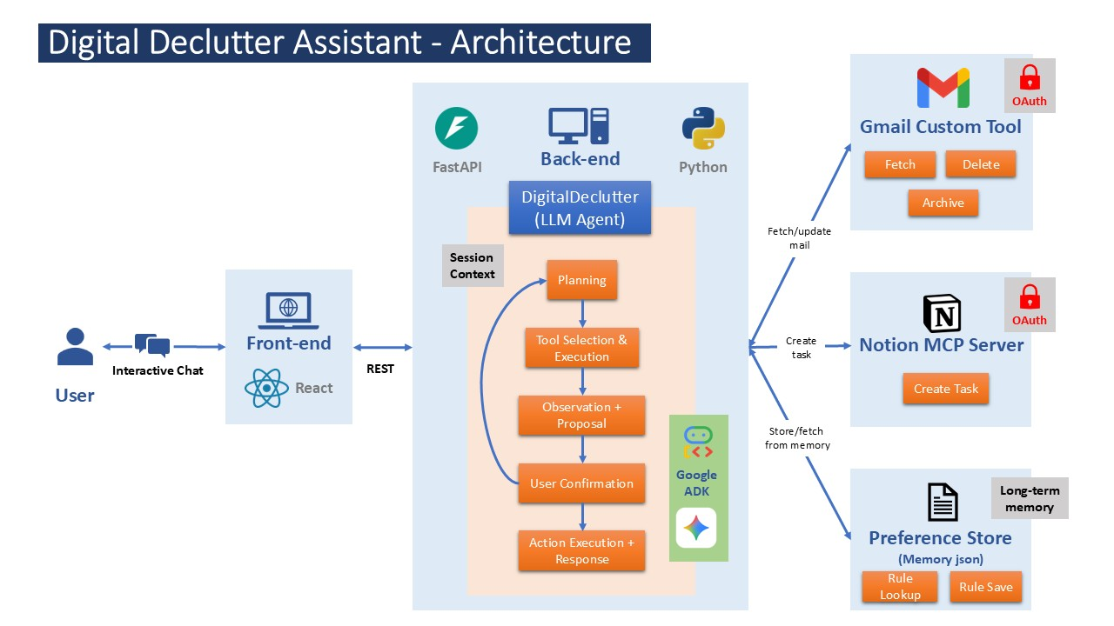
The system has five major components:
1. Front-end (React)
A simple conversational UI that feels like chatting with Gmail itself.
User messages → REST → backend → agent.
2. Backend (FastAPI + Python)
Hosts:
- Google ADK agent
- MCP tool connections
- OAuth for Gmail
- Memory store
- Request → event loop → agent run execution
3. LLM Agent (Google ADK)
The “brain” of the system.
It performs the agent loop:
- Planning
- Tool selection & execution
- Observation & proposal
- User confirmation
- Final action & response
It uses:
- Gemini 2.5 Flash Lite for fast reasoning
- ADK Runner for step-wise execution
- Session context to maintain short-term memory
4. Tools
Gmail Custom Tool
- Fetch recent emails
- Archive email
- Delete email
- Update labels
Notion MCP Server
- Create structured Notion tasks
- Pass typed metadata (title, sender, due date, description)
This is the Model Context Protocol component allowing standardized tool usage.
Preference Store (Memory JSON)
Stores long-term user rules:
- Always archive newsletters from X
- Mark emails from Y as Important
- Always convert invoices to tasks
5. Integration Flow
The flow for a single user request:
User → React UI → FastAPI → ADK Agent → Gmail/Notion/Memory Tools → Agent → User
Agent Loop
The core loop shown in the architecture:
User request → Planning → Tool Selection & Execution → Observation + Proposal → User Confirmation → [If confirmed → Action Execution + Response | else → repeat Planning (feedback loop)]
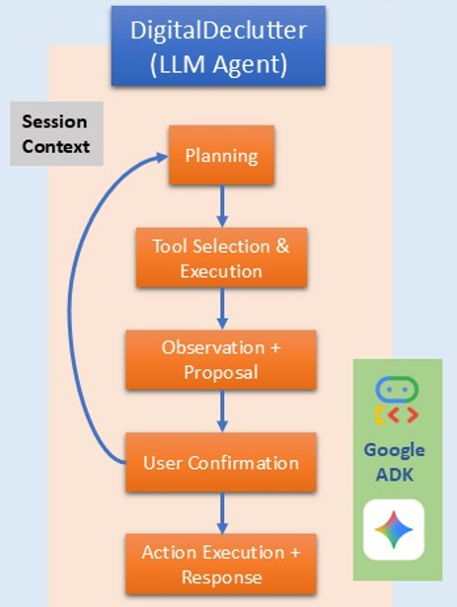
This loop continues until:
- The work is complete
- Or the user decides to stop
What Learning Is Used Where
- Reasoning: Gemini Flash Lite + ADK LlmAgent
- Structured decision-making: ADK tool schemas
- Human-in-the-loop: Confirmation stage
- Long-term memory: PreferenceStore
- Custom Tool: Gmail custom tool API
- Interoperability: MCP server for Notion
- Async execution: FastAPI backend
Demo Summary
Here is what an interaction looks like:
1. User: “Check my inbox and tell me what needs action.”
Agent:
- Fetches emails
- Identifies categories: Important, Promotional, Updates
- Highlights 2 actionable tasks
- Asks for confirmation
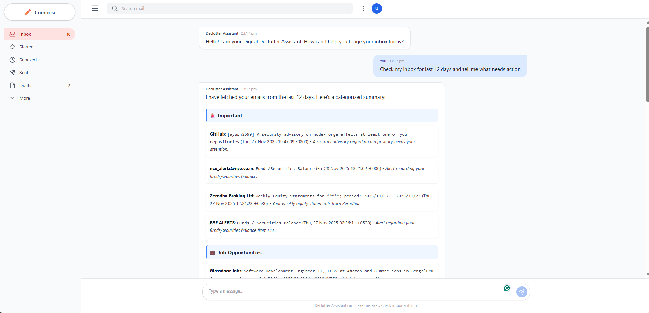
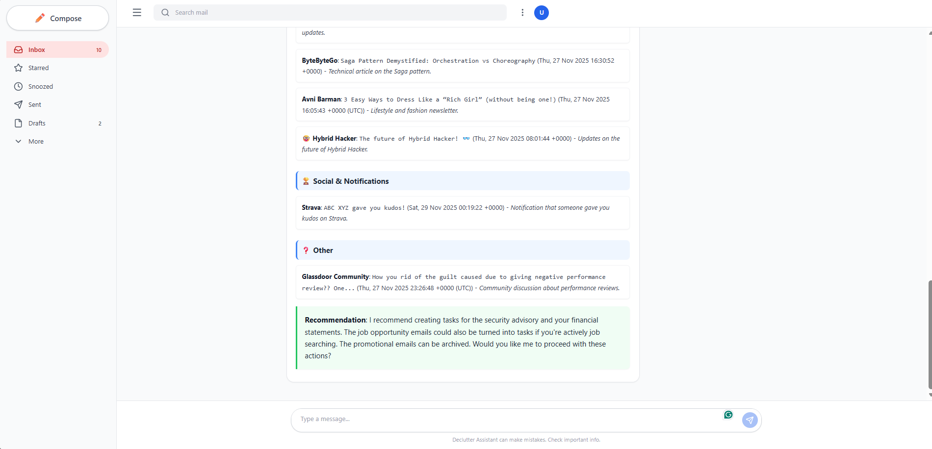
2. User: “Create tasks for the actionable ones and archive the rest.”
Agent:
- Creates two Notion tasks
- Archives 14 emails
- Saves a rule: “Always archive ByteByteGo newsletters”
Everything happens through a conversational interface with transparent reasoning.
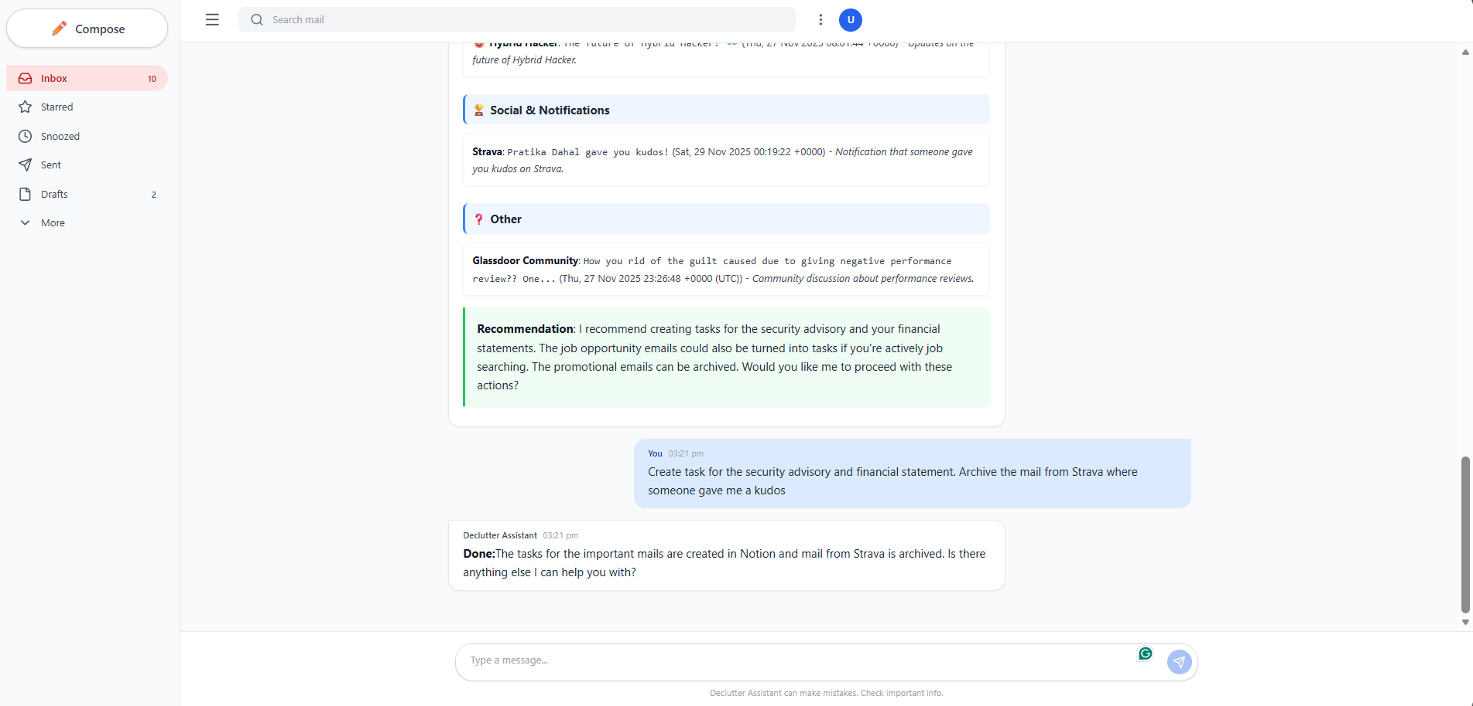
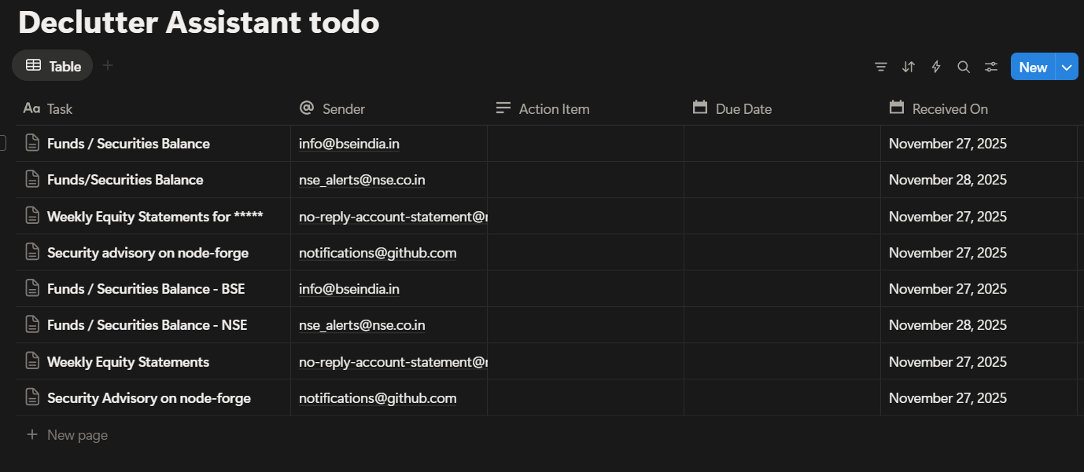
The Build: How It Was Created
1. Google ADK
I used ADK to build the LLM agent with:
- LlmAgent
- Runner
- Session service
- Event streaming (text, tool call, observation, proposals)
ADK guaranteed deterministic tool execution and avoided hallucinated tool calls.
2. Gemini 2.5 Flash Lite
Used for reasoning:
- Fast enough for real-time chat
- Cheap for repeated tool cycles
- Strong planning ability
3. Gmail API
Built custom Python tools:
- OAuth2 flow
- Token refresh
- List → get → decode → parse
- Batch processing
- Label modifications for archive/delete
4. Notion MCP Server
One of the most challenging components:
- Built using Python FastMCP
- Exposed create_task as MCP tool
- Input schema validation ensured correct task formation
- Converted natural language fields into Notion-compliant JSON objects
5. Memory Store
A simple JSON file with:
- Sender preferences
- Archive rules
- Important email rules
It is loaded on each agent cycle so the agent remembers previous user choices.
6. Frontend (React + Vite)
- Chat interface
- Markdown rendered responses
- Smooth UX resembling AI chat apps
- REST communication with backend
7. Backend (FastAPI)
- Async route /chat
- Lazy initialization of MCP to avoid Windows fileno bug
- Streaming-like behavior for agent run events
- Error boundaries for robust execution
Challenges I Solved
1. MCP crashing on Windows
Fixed using lazy initialization inside the request cycle.
2. Notion property validation failures
Solved via custom wrapper to enforce strict schema formatting.
3. Gmail Base64 decoding + payload parsing
Built a robust parser that extracts snippet, sender, timestamp reliably.
4. Maintaining agent state without chat history overload
Used ADK session + external memory store.
If I Had More Time, I Would:
1. Add Vector Database for Semantic Email Search
Store all email embeddings → enable queries like:
- “Find receipts from last summer”
- “Show all messages about my travel plans”
2. Multi-user Platform
Replace local JSON memory with SQLDB or PostgreSQL and make it usable by multiple users.
3. Voice Mode
Use Gemini’s multimodal features:
- Listen to “Check my inbox while I’m driving”
- Read summaries out loud
4. Auto-rule generation
Allow the agent to proactively generate rules from patterns over time.
5. Real-time streaming
Add token streaming for smoother UI.
6. More tools
- Calendar event creator
- Drive file extractor
- Slack inbox triager
- Outlook email integration
Conclusion
Digital Declutter Assistant is more than a project; it is a personal digital partner that blends understanding, automation, and reliability.
This submission demonstrates:
- Real-world impact
- Sophisticated agentic architecture
- End-to-end engineering across front-end, backend, tools, and memory
- Practical application of Google ADK, Gemini, MCP, OAuth, FastAPI
- A robust agentic loop with human guardrails
It showcases the capabilities learned and expected in Google x Kaggle Agents Intensive course:
A complete, functional agent system solving a real human problem.

